Experiment 10
- Internetworking with routers in CISCO PACKET TRACER simulator.
AIM: To design a internetwork with routers in CISCO PACKET TRACER simulator
Procedure: Internetworking with Routers in Cisco Packet Tracer
- Open Cisco Packet Tracer and place two routers, two switches, and PCs in the workspace.
- Connect the PCs to the switches and the switches to the routers using suitable cables.
- Assign IP addresses and subnet masks to all PCs.
- Configure IP addresses on the router interfaces using the CLI.
- Enable the router interfaces using the no shutdown command.
- Configure routing between the networks using static routes or a suitable routing protocol.
- Verify connectivity by using the ping command between PCs in different networks.
- Observe packet transmission in Simulation Mode and verify successful internetwork communication.
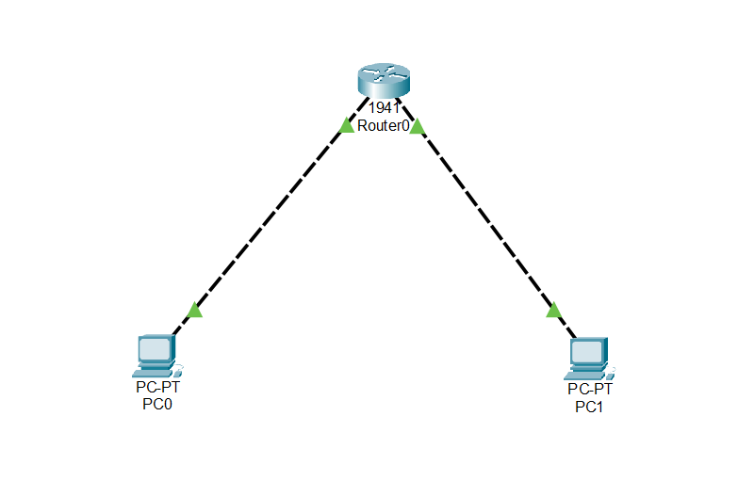
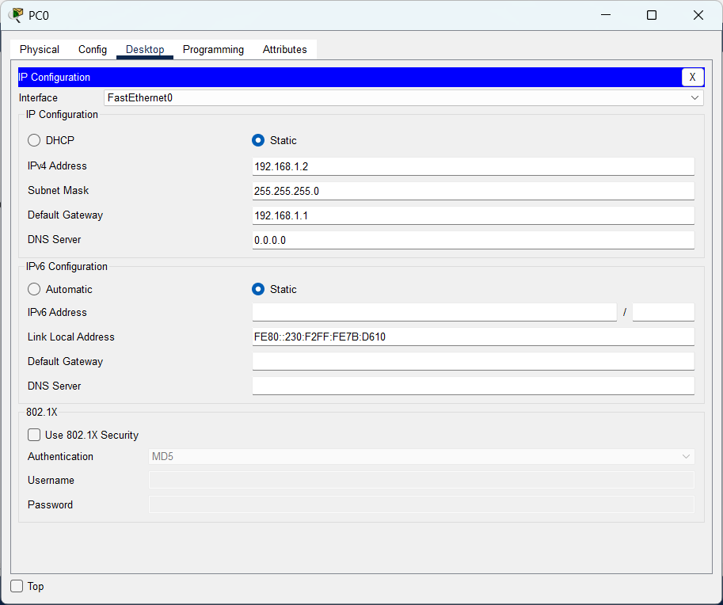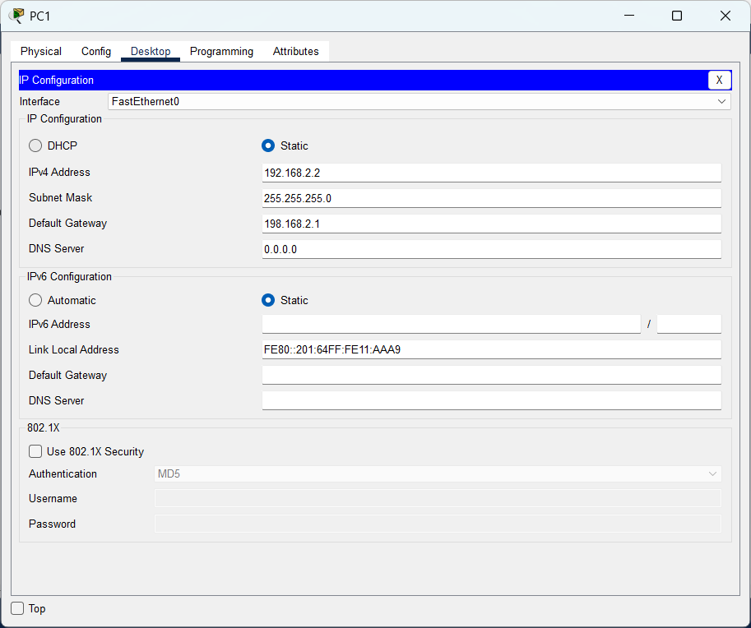
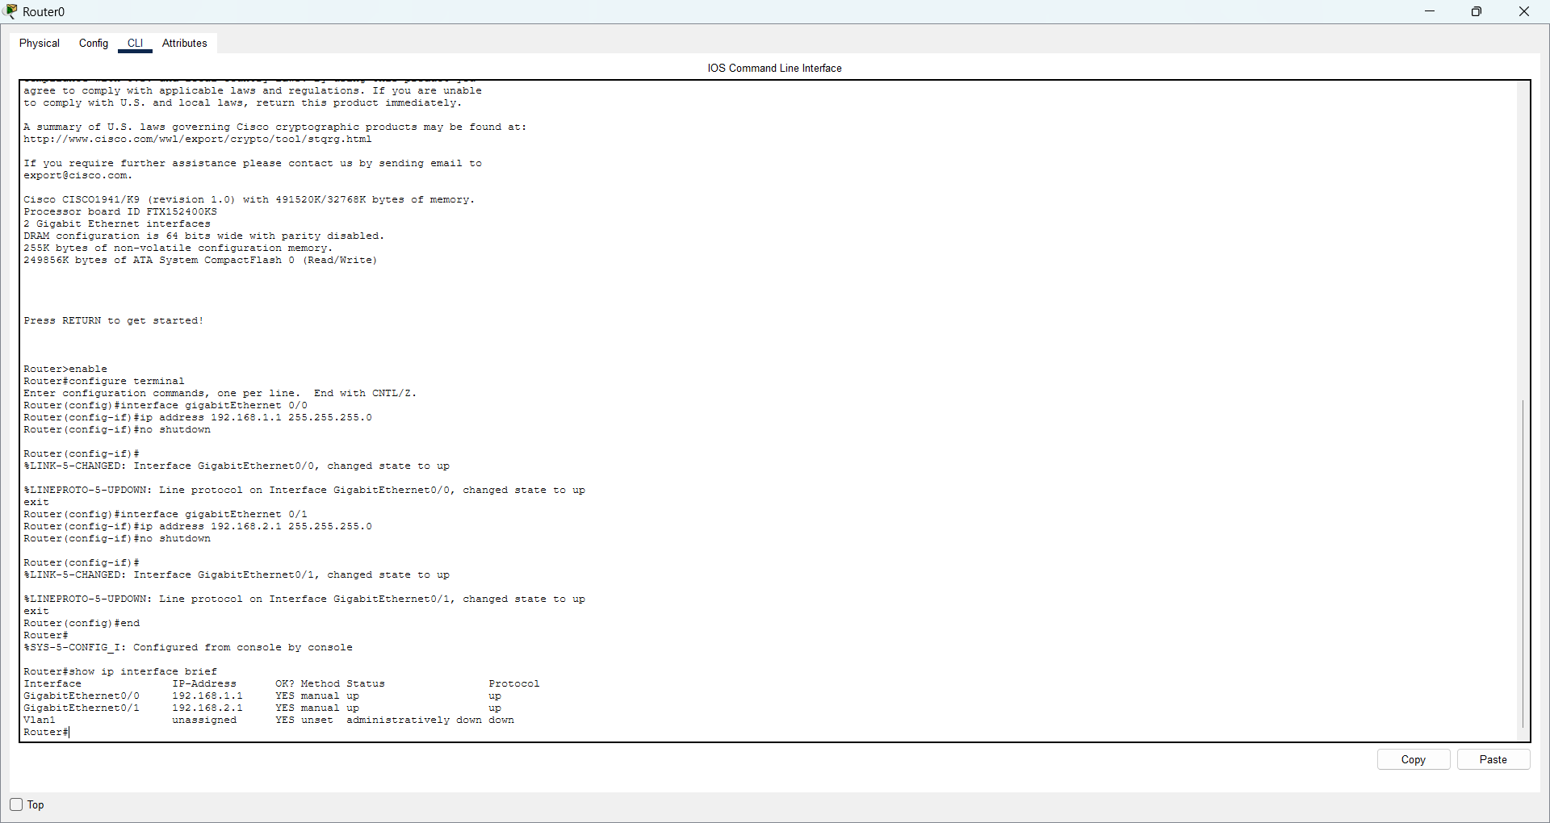
Router Configuration
enable
configure terminal
interface gigabitEthernet 0/0
ip address 192.168.1.1 255.255.255.0
no shutdown
exit
interface gigabitEthernet 0/1
ip address 192.168.2.1 255.255.255.0
no shutdown
exit
end
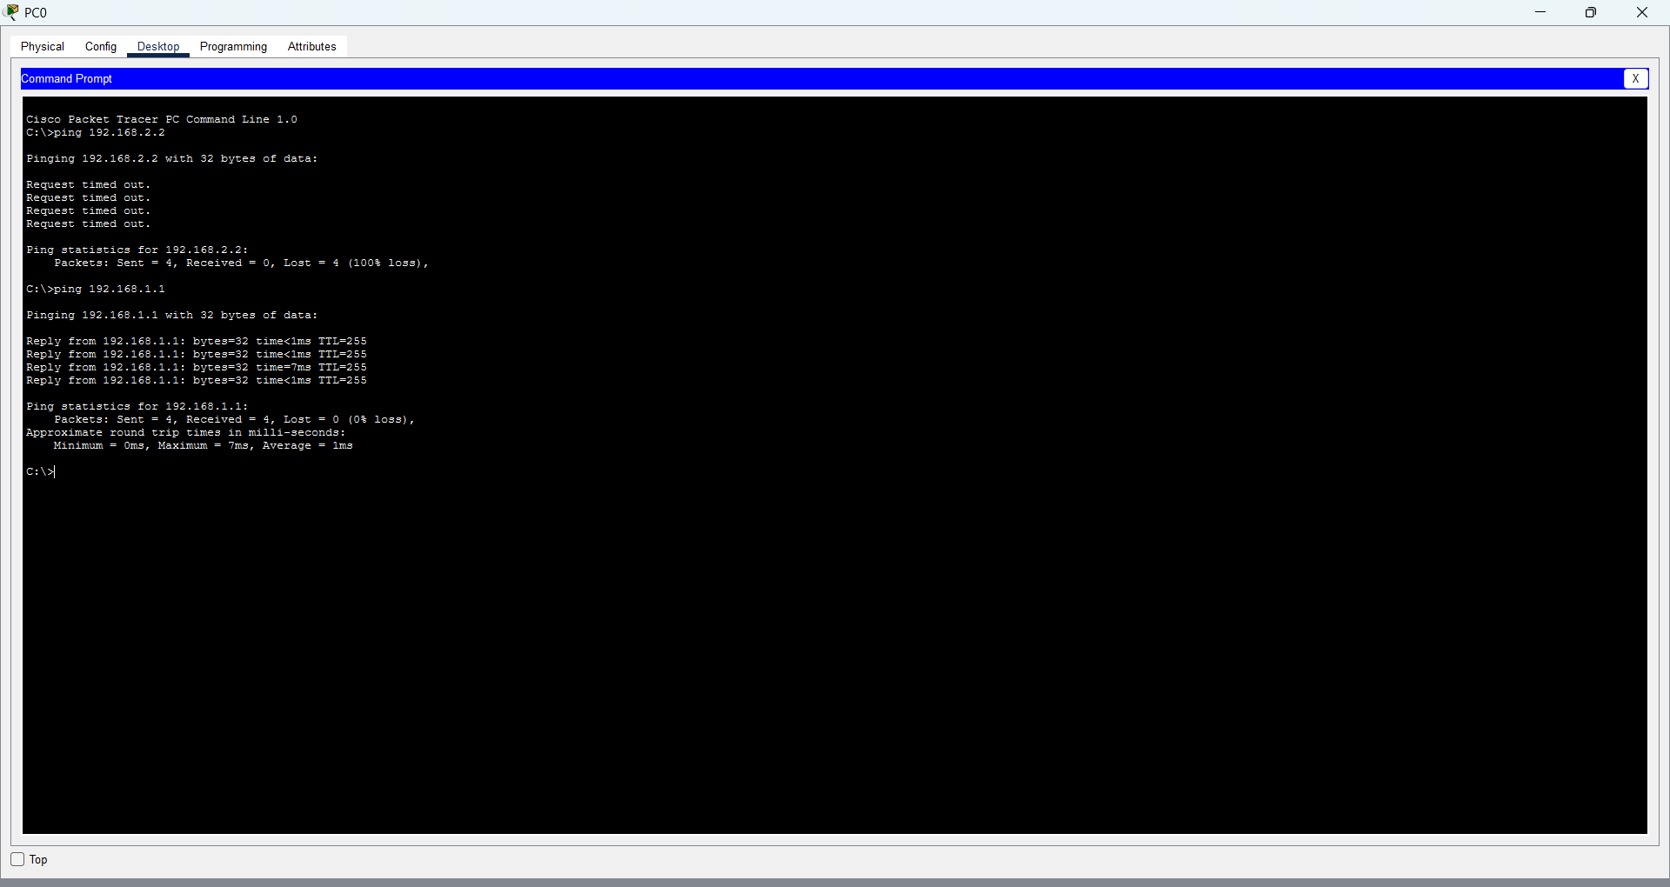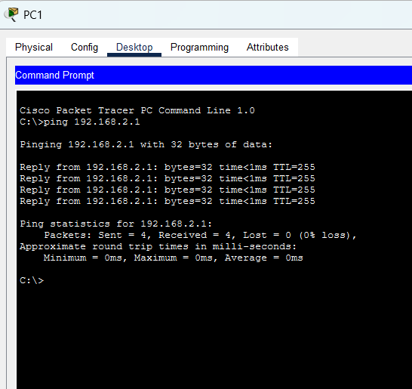
- Design and configure an internetwork using wireless router, DHCP
server and internet cloud.
AIM: To Design and configure an internetwork using wireless router, DHCP server and internet cloud
Procedure:
- Open Cisco Packet Tracer and place a wireless router, DHCP server, PCs/laptops, and an Internet cloud.
- Connect the DHCP server and Internet cloud to the wireless router using suitable cables.
- Configure the DHCP server with a static IP address and enable the DHCP service.
- Set the DHCP pool with the network address, subnet mask, default gateway, and starting IP address.
- Configure the wireless router with the required IP address and wireless SSID.
- Connect laptops to the wireless network using the SSID and password.
- Set the PCs and laptops to obtain IP addresses automatically using DHCP.
- Configure the router's Internet/WAN settings as required.
- Verify connectivity by checking assigned IP addresses and using the ping command.

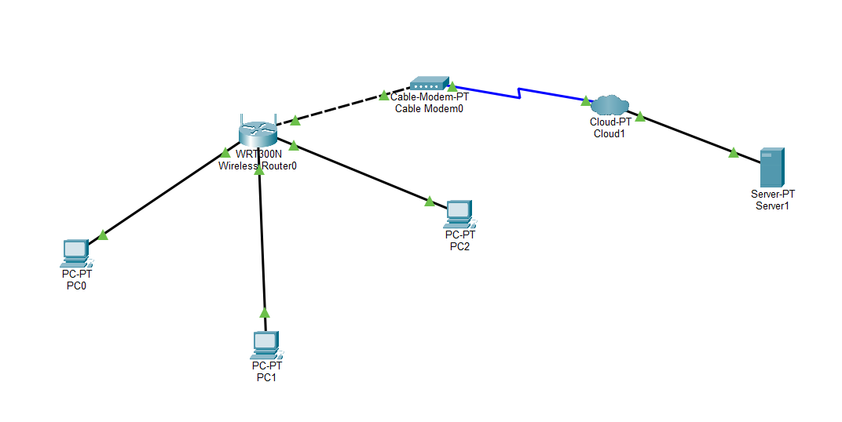
Step 1:
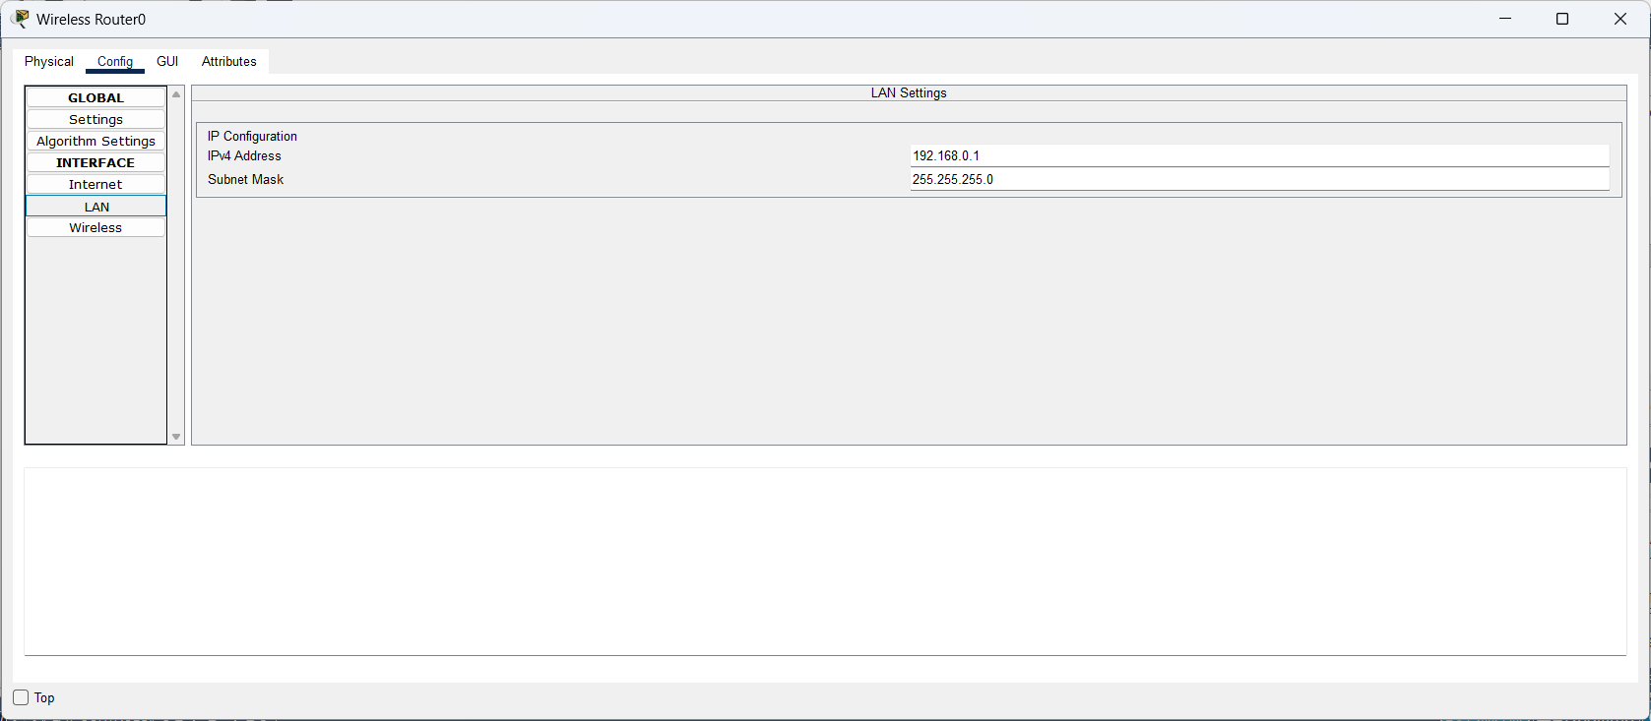
Step 2:
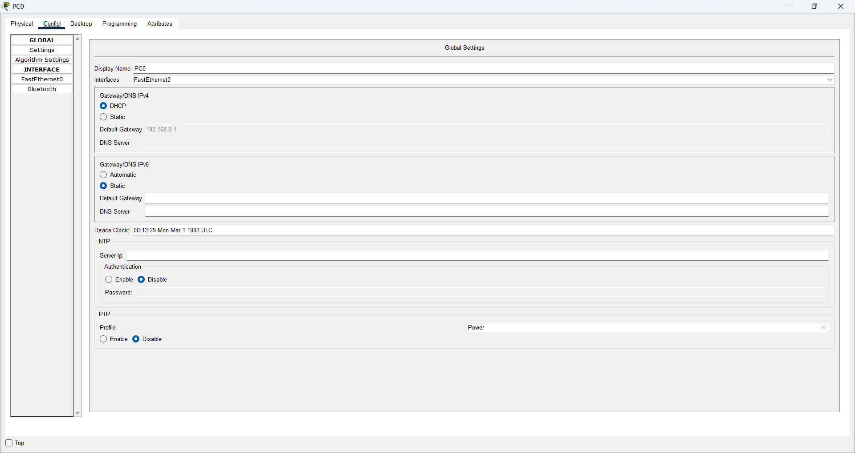
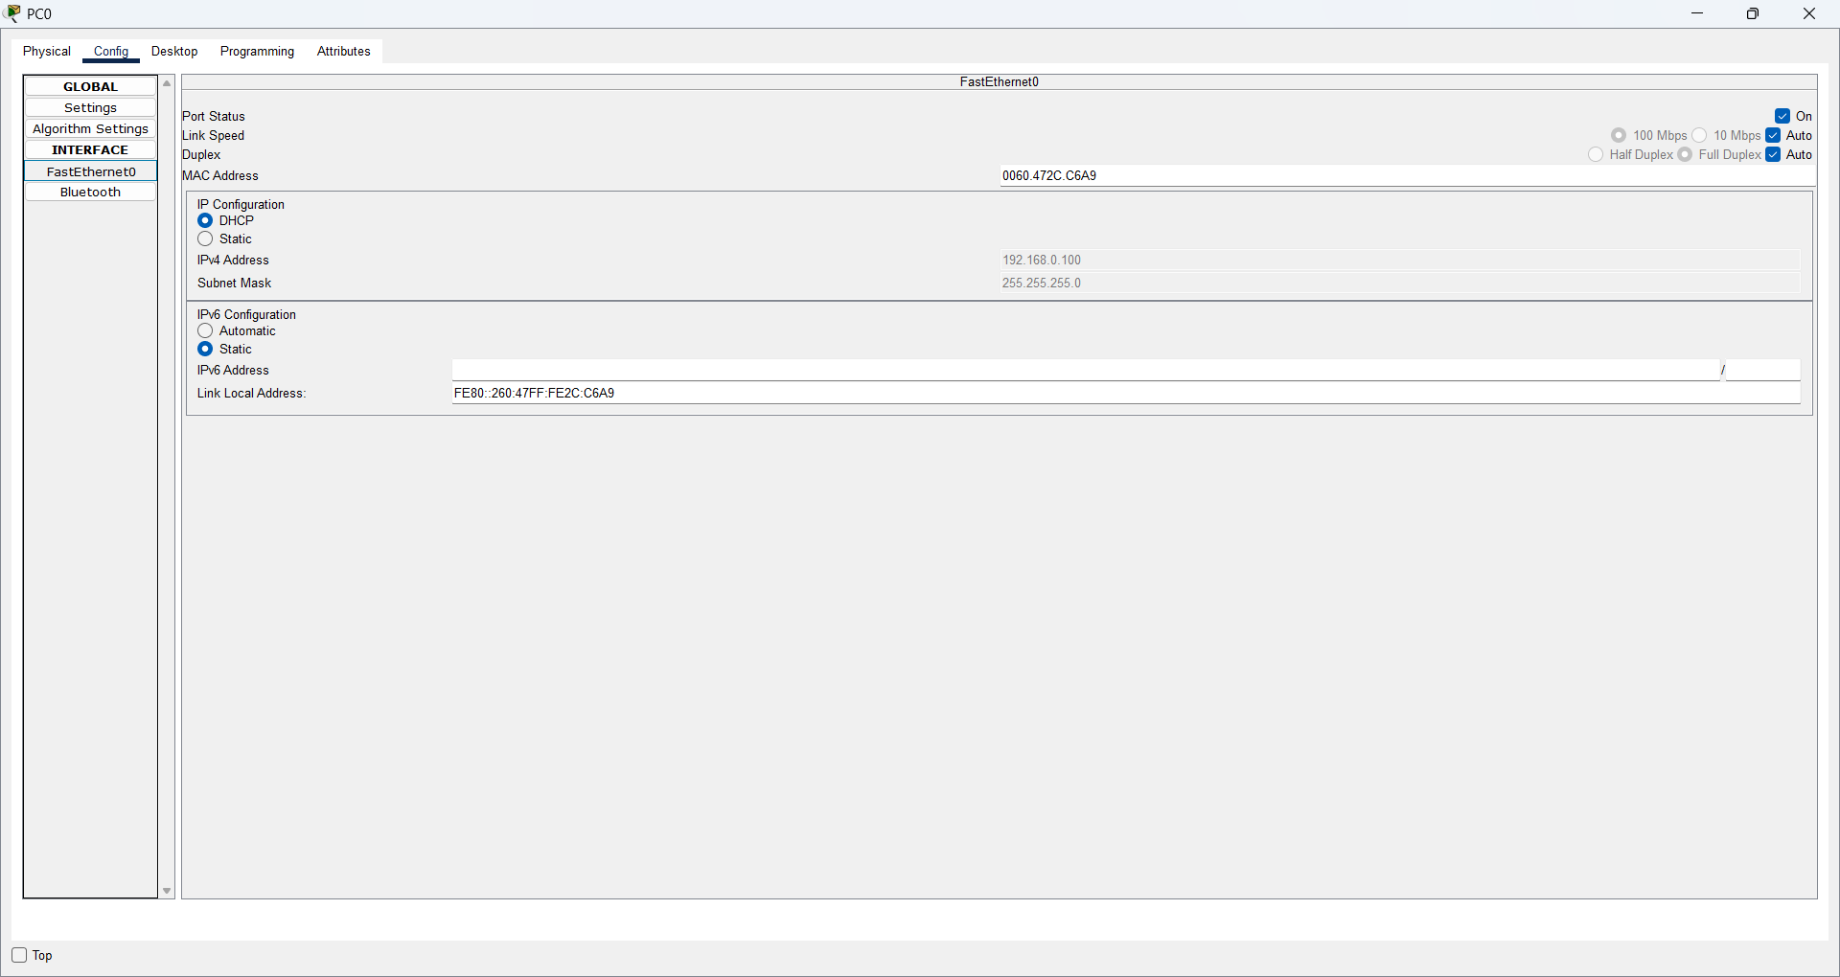
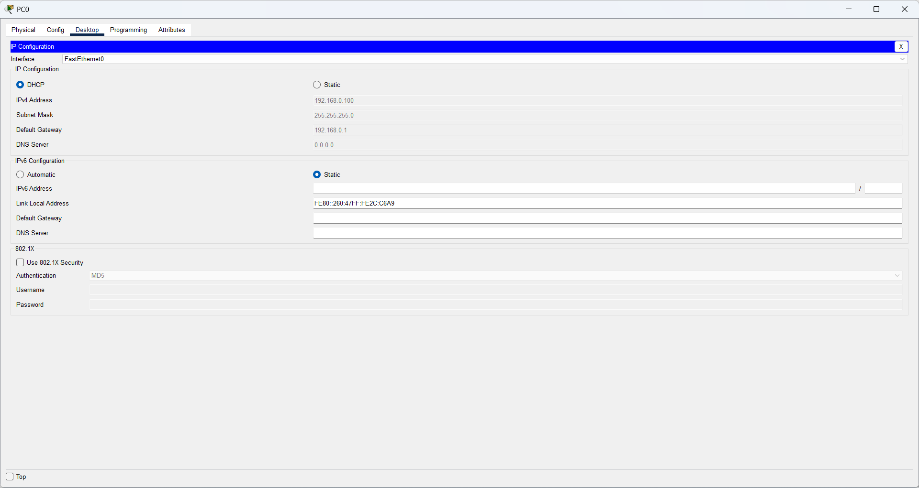
Step 3:
Same for PC1 and PC 2 and then connect the elements shown in the picture use Automatic cable

